***How To Play My Mario Game***

**Step-1 : Go to mygame -> code -> open only the code folder in visual studio code.**

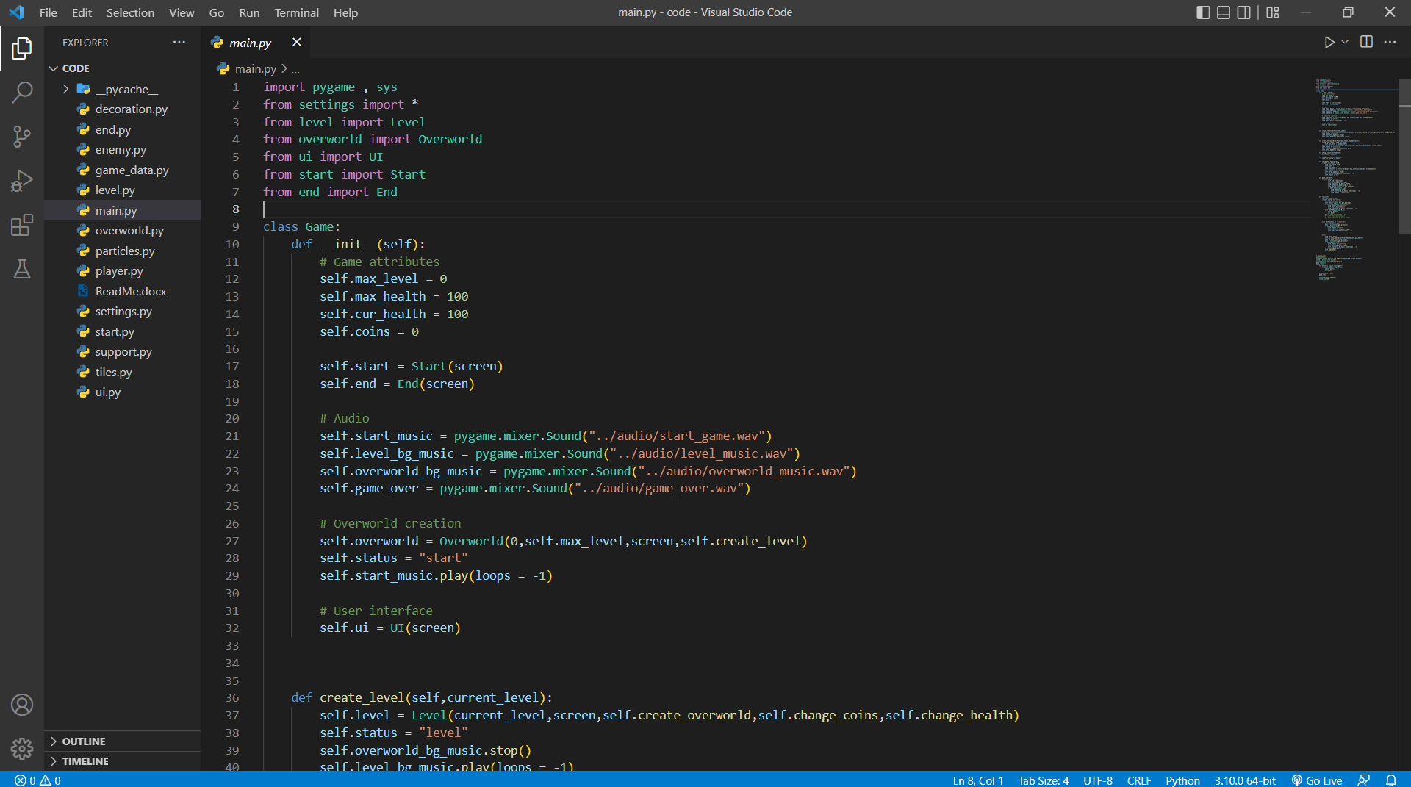

**Step-2 : Go to main.py**

**-> Open terminal or command prompt and Run :**

**pip install pygame**

**pip install sys**

**Step-3 : Run main.py file (Shift+Enter)**

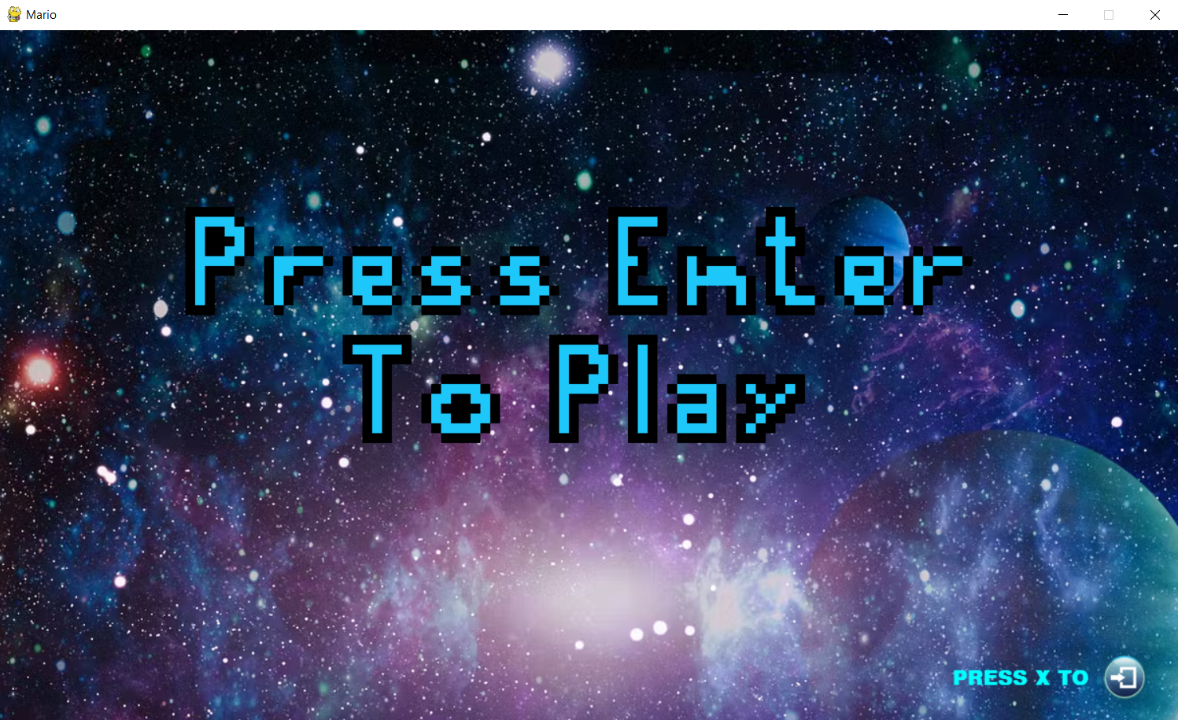

**( This screen should be there. )**

**Step-4 : press Enter**

**(Note : - press enter the one which is in the image below )**

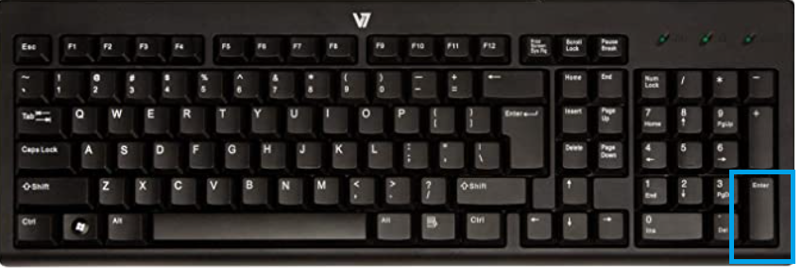

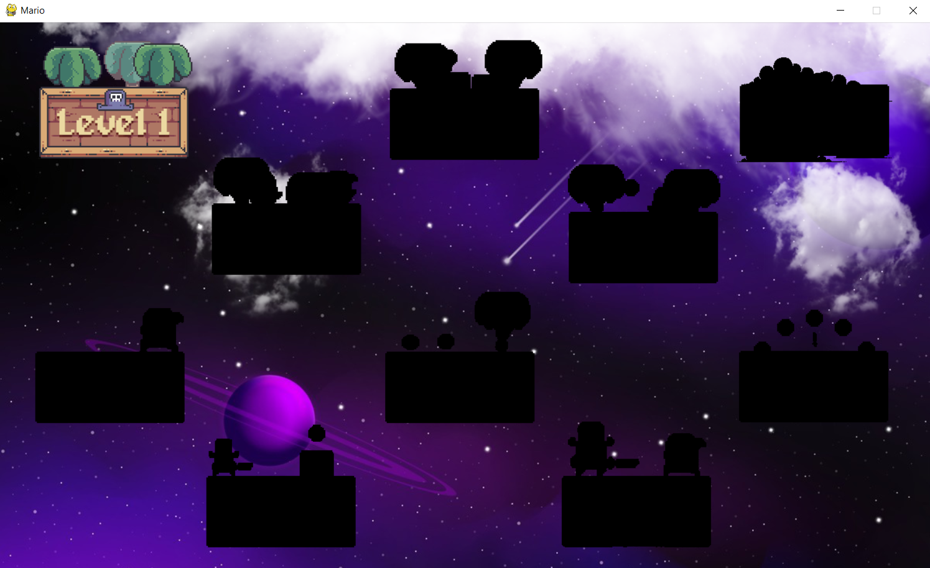

**( After pressing enter this screen should be there. This is overworld. )**

**Step-5 : press space to start playing.**

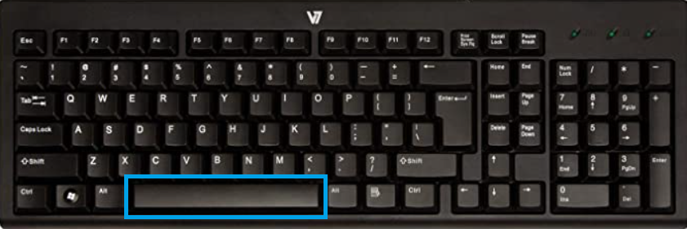

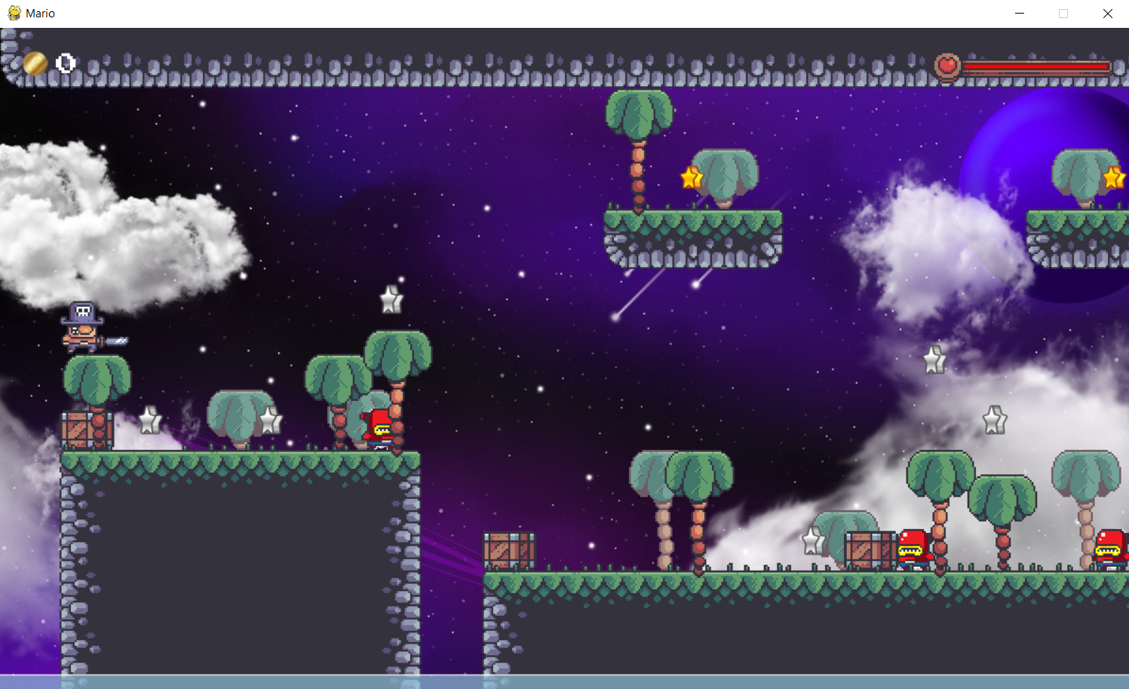

**( After pressing space this screen should be there. )**

**Step-6 : press left or right to move and**

**Press space to jump.**

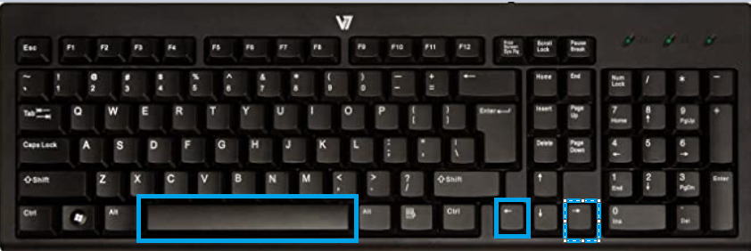

**Collect coins and move on.**

**Step-7 : As levels continue to be completed, the next levels will be opened.**

**( Note : - Keep an eye on the health bar , if the health is exhausted then you will have to start from the first level.)**

**Step-8 : If the game is over , press q**

**( Note : - At the end of each level , Mario will get a fruit basket. That he can eat to satisfy his hunger in space.)**

**Step-9 : Press x to go from game to level selection(Overworld).**

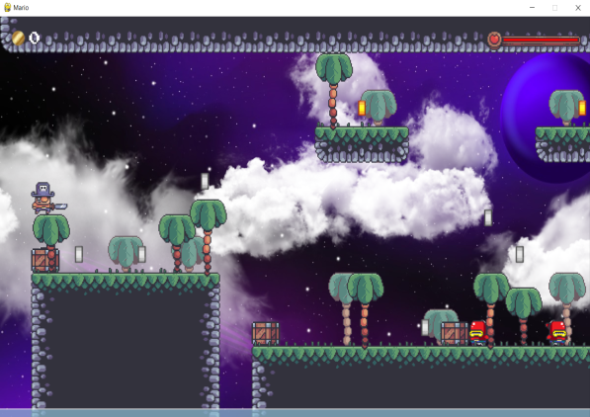 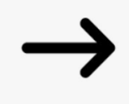 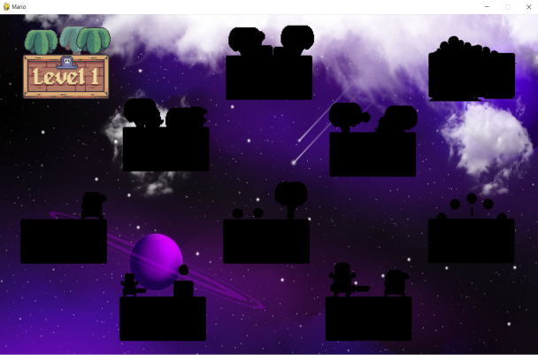

**Step-10 : Press e to go from overworld to main menu.**

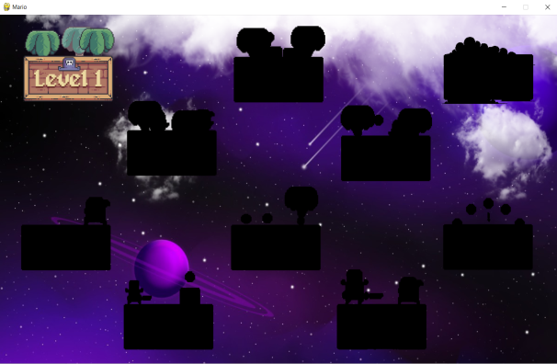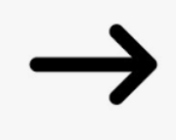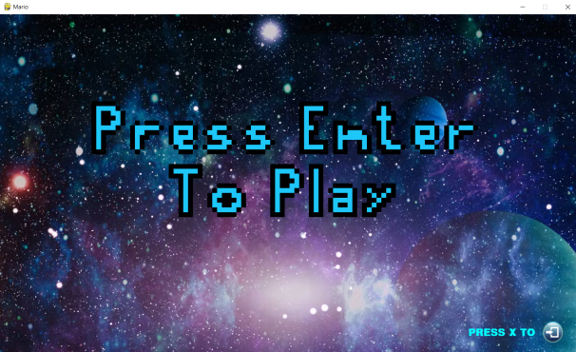

**Step-11 : Press x in the main menu to exit the game.**

**If you have reached 10th level then there is a lot of fun in it.**



